# Scenario: Debugging Assignment

## Scenario Description

* Patron wants to borrow a book and the test scripts will go over the different situations where this will be achieved successfully or unsuccessfully.

## Version Control

|  |  |  |  |
| --- | --- | --- | --- |
| Version # | Date | Author | Description |
| 0.1 | 12/10/2019 | Adam Tolo | Initial Draft |
| 1.0 | 18/10/2019 | Adam Tolo | Initial Version |

## Test Scripts

The following scripts will cover this scenario:

* 1.1 Player loses double on loss
* 1.2 Player doesn’t receive any winnings
* 1.3 Player cannot reach betting limit
* 1.4 Odds in game are incorrect

## Use Case

* Player can play the Hoo Hey How Game and it is reflective of the rules of the game. The odds of winning should also be as what has been defined as standard

## Script #1.1: Player loses double on loss

### Script Description

* Player’s loss amount is double the amount they bet after each round

### Testing Requirements

This test script covers the following specific testing requirements:

* If a player loses, they should only lose the amount they bet

### Setup

* Run Main.java

### Teardown

* NA

### Script Steps

| **Step #** | **Test Action** | **Expected Results** | **Pass/ Fail** |
| --- | --- | --- | --- |
| 1 | Player types p and pressed <enter> | Program asks user to enter player name | P |
| 2 | Player types in Adam and presses <enter> | Program asks user to enter initial balance | P |
| 3 | Player presses <enter> | Program asks user to enter limit | P |
| 4 | Player presses <enter> | Program asks user to enter standard bet | P |
| 5 | Player presses <enter> | Program displays the entered details and then asks user which symbol to select. Lists the options of 1 - Fish, 2 - Prawn, 3 - Crab, 4 - Rooster, 5 - Gourd, 6 – Stag for options | P |
| 6 | Player presses 4 | Program asks for bet amount | P |
| 7 | Player presses <enter> | Program should display  Adam lost 10, balance now 90 | F |
|  |  | NEED TO ADD IF STATEMENT ABOVE |  |

### Evidence of Result

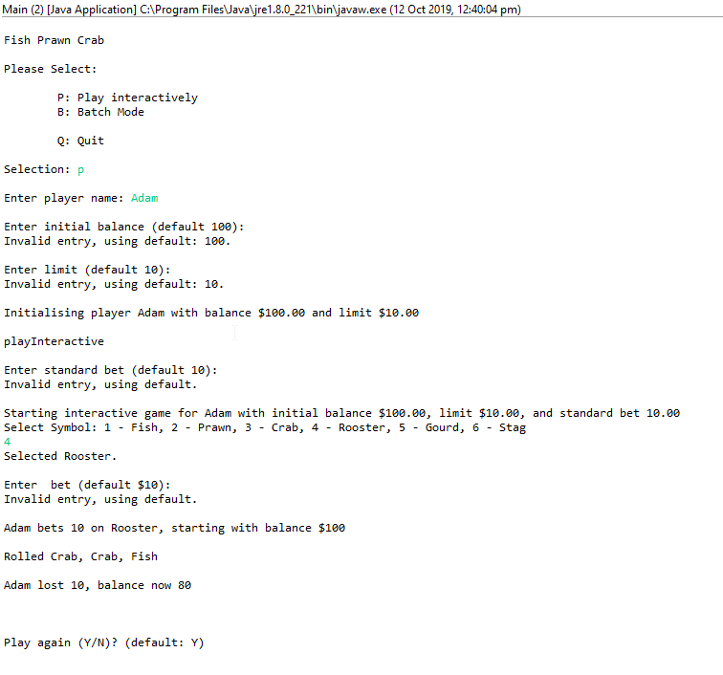

### Test Execution

|  |  |  |  |  |
| --- | --- | --- | --- | --- |
| Date/Time | Tester | Test ID | Test Phase | Status |
| 12/10/19 12:41pm | Adam Tolo | Adatol | System Cycle 1 | Failed |
| 12/10/19 12:52pm | Adam Tolo | Adatol | System Cycle 2 | Failed |

## Script #1.2: Player doesn’t receive any winnings

### Script Description

* After a player wins, their balance stays the same

### Testing Requirements

This test script covers the following specific testing requirements:

* If a player winning, they balance should increase by the amount they bet

### Setup

* Run Main.java

### Teardown

* NA

### Script Steps

| **Step #** | **Test Action** | **Expected Results** | **Pass/ Fail** |
| --- | --- | --- | --- |
| 1 | Player types p and pressed <enter> | Program asks user to enter player name | P |
| 2 | Player types in Adam and presses <enter> | Program asks user to enter initial balance | P |
| 3 | Player presses <enter> | Program asks user to enter limit | P |
| 4 | Player presses <enter> | Program asks user to enter standard bet | P |
| 5 | Player presses <enter> | Program displays the entered details and then asks user which symbol to select. Lists the options of 1 - Fish, 2 - Prawn, 3 - Crab, 4 - Rooster, 5 - Gourd, 6 – Stag for options | P |
| 6 | Player presses 1 | Program asks for bet amount | P |
| 7 | Player presses <enter> | Program should display  Adam won 10, balance now 110 | F |

### Evidence of Result

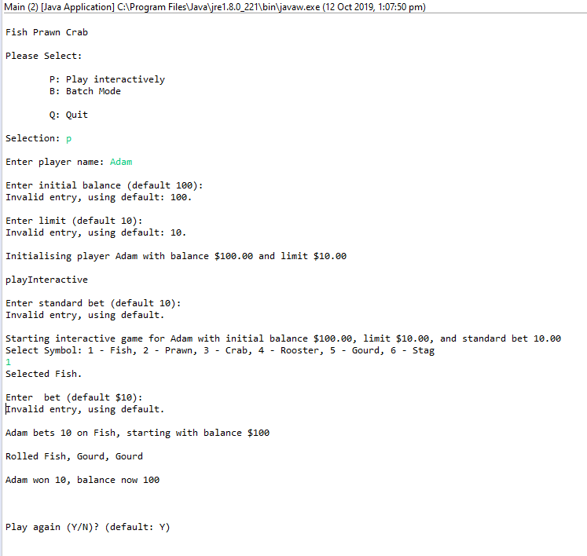

### Test Execution

|  |  |  |  |  |
| --- | --- | --- | --- | --- |
| Date/Time | Tester | Test ID | Test Phase | Status |
| 12/10/19 13:07pm | Adam Tolo | Adatol | System Cycle 1 | Failed |
| 12/10/19 13:10pm | Adam Tolo | Adatol | System Cycle 2 | Failed |

## Script #1.3: Player cannot reach betting limit

### Script Description

* When a player tries to make a bet which if they lose would take them to their betting limit, the bet is void

### Testing Requirements

This test script covers the following specific testing requirements:

* A player should be able to reach the exact number of their betting limit but not be able to go under the limit

### Setup

* Run Main.java

### Teardown

* NA

### Script Steps

| **Step #** | **Test Action** | **Expected Results** | **Pass/ Fail** |
| --- | --- | --- | --- |
| 1 | Player types p and pressed <enter> | Program asks user to enter player name | P |
| 2 | Player types in Adam and presses <enter> | Program asks user to enter initial balance | P |
| 3 | Player presses <enter> | Program asks user to enter limit | P |
| 4 | Player presses <enter> | Program asks user to enter standard bet | P |
| 5 | Player presses <enter> | Program displays the entered details and then asks user which symbol to select. Lists the options of 1 - Fish, 2 - Prawn, 3 - Crab, 4 - Rooster, 5 - Gourd, 6 – Stag for options | P |
| 6 | Player presses 1 | Program asks for bet amount | P |
| 7 | Player types 90 and presses <enter> | Program should display  Adam lost 90, balance now 10 | F |

### Evidence of Result

### Test Execution

|  |  |  |  |  |
| --- | --- | --- | --- | --- |
| Date/Time | Tester | Test ID | Test Phase | Status |
| 13/10/19 xx:xxpm | Adam Tolo | Adatol | System Cycle 1 | Failed |
| 13/10/19 xx:xxpm | Adam Tolo | Adatol | System Cycle 2 | Failed |

## Script #1.4: Odds in game are incorrect

### Script Description

* After 10,000 rounds the ratio of wins should be near 0.42.

### Testing Requirements

This test script covers the following specific testing requirements:

* If a player played 10,000 rounds, their win ratio should be near 0.42

### Setup

* Win ratio not displayed on screen. Modified BatchModeGame.java to include the ratio of wins after 10,000 rounds.
* Run Main.java
* Use all the default values except for when it asks for the starting balance. Make it 1,000,000 so that it never gets to 0

### Teardown

* NA

### Script Steps

| **Step #** | **Test Action** | **Expected Results** | **Pass/ Fail** |
| --- | --- | --- | --- |
| 1 | Player types b and pressed <enter> | Program asks user to enter player name | P |
| 2 | Player types in Adam and presses <enter> | Program asks user to enter initial balance | P |
| 3 | Player types 1000000 presses <enter> | Program asks user to enter limit | P |
| 4 | Player presses <enter> | Program asks user how many games to play? | P |
| 5 | Player types 10000 and presses <enter> | Program asks user to enter standard bet |  |
| 6 | Player presses <enter> | Program displays the entered details and then asks user if they want a standard pick or random | P |
| 7 | Player types R and presses <enter> | Program displays the final balance after 10000 rounds and displays the ratio of wins. The ratio of wins should be 0.42 +-0.01 | F |

### Evidence of Result

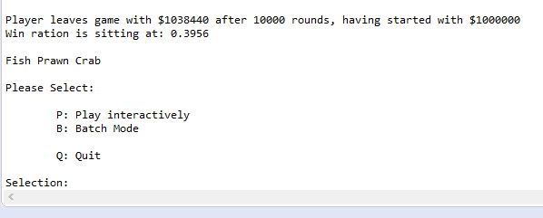

### Test Execution

|  |  |  |  |  |
| --- | --- | --- | --- | --- |
| Date/Time | Tester | Test ID | Test Phase | Status |
| 15/10/19 21:39pm | Adam Tolo | Adatol | System Cycle 1 | Failed |
| 15/10/19 21:45pm | Adam Tolo | Adatol | System Cycle 2 | Failed |